Blair Wong

PPUA 5262

Wednesday, February 8th

City Exploration #1 – Tour of Jamaica Plain

# Introduction

This city exploration will provide a tour of a census tract (120400) within the Jamaica Plain neighborhood. For this city exploration, I used census tract-level data rather than neighborhood-level data to determine which listings are in Boston and its surrounding cities so that I could include more data than filtering with the `LOCATION` variable. In order to use census tract-level data, I imported the 207 census tract IDs within Boston from the Federal Communications Commission. For the surrounding cities, I imported the census tract IDs from the Statistical Atlas.

# Three New Variables

#### IN_BOSTON

This variable indicates whether the census tract is within the city of Boston or in one of the surrounding cities. An `ifelse` statement was used to indicate whether the census tract ID was in Boston or outside of Boston. If the census tract was in Boston, then it would be assigned a value of 1 and if it was outside of Boston, then it would be assigned a value of 0. The purpose of this variable is to allow us to easily compare and filter listings based on whether they are in the city or not. In the case of the census tract in Jamaica Plain, we can quickly compare 120400’s listing prices with listings outside of the city so that we can better comprehend and understand why prices are higher or lower outside city limits. The `IN_BOSTON` flag also helps future users of the data outside of the Boston area who are unfamiliar with the neighborhoods and surrounding cities to quickly determine whether the listing they are observing is within city limits.

#### PRICE_PER_SQ_FT

The `PRICE_PER_SQ_FT` variable is calculated by dividing the price of the listing by the square footage. This variable allows us to compare listings whose unit sizes differ depending on the number of bedrooms. With this variable, we can compare a one-bedroom with a four-bedroom apartment. One consideration when creating this variable was the listings where people only advertised one bedroom as part of a shared apartment. These listings skewed the results because the listings would provide the square footage of the bedroom, but the cost for accessing the entire apartment, resulting in a significantly higher price per square footage value. Additionally, because Craigslist does not validate the listing prices or square footage, there were some listings that had drastically high values that did not make sense. To clean up the data and exclude outliers, I required the prices to remain above $400 and the square footage to be between 500 and 3,000 square feet.

#### LISTING_DATE

Since the Craigslist data provides dates three separate variables (`LISTING_DAY`, `LISTING_MONTH`, `LISTING_YEAR`), we can only compare listings across days, months, or years. In order to create a time series plot, we need to combine the variables. The variable `LISTING_DATE` is the `LISTING_MONTH` and `LISTING_YEAR` combined with the day set as the first of the month. The reason for using the first of the month rather than the `LISTING_DAY` value is to have even time intervals. In general, the `LISTING_DATE` variable allows us to view the data continuously and chronologically.

#### Average Price Per Square Foot Over Time in Jamaica Plain Compared to Cities Outside of Boston

In **Figure 1**, we can see a combination of all three variables in one plot. The plot shows the average price per square foot over time in the census tract 120400 compared to census tracts outside of Boston.

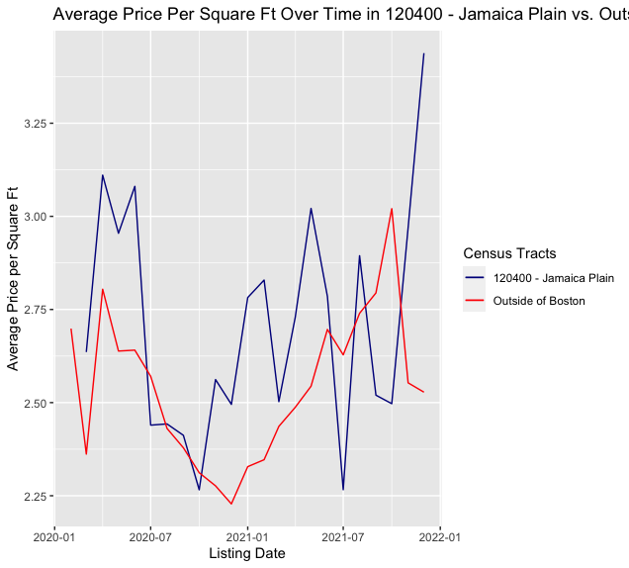

**Figure 1.** Average Price per Square Foot in Census Tract 120400 vs. Census Tracts outside of Boston

Based on the plot, we can see that the average price per square foot for both census tract 120400 and tracts outside of Boston generally follow the same pattern, with 120400 having more variation. This is expected since 120400 has less data points than listings outside of Boston. For both 120400 and listings outside of Boston, there is a dip in prices around the late fall and early winter of 2020, but the prices rose after 2021. There is a substantial dip in price for 120400 in July 2021 that is not seen in listings outside of Boston, but in the fall of 2021, as the listings outside of Boston reached a peak and declined, 120400’s listing prices kept increasing. The peak in the listings outside of Boston could likely be accounted for in the rising prices that align with the school calendar. For example, with Harvard and MIT in Cambridge, prices in Harvard Square, Kendall Square, and Central Square likely increased in September of 2021 to coincide with the return of students. Unlike Cambridge, Jamaica Plain does not have the same concentration of university students, which possibly kept their prices more stable in the fall of 2021. Additionally, the main difference between Fall 2020 and Fall 2021 could be the effects of the COVID-19 pandemic. In Fall 2020, most universities were still remote and there was significantly less demand.

# Exploring Census Tract 120400 – Jamaica Plain

#### Background

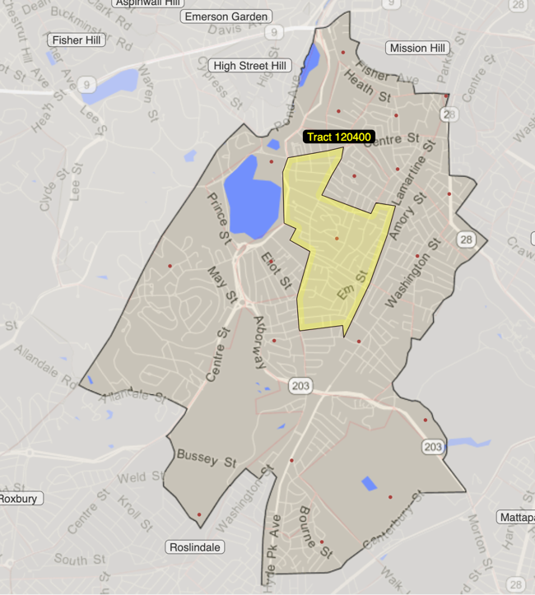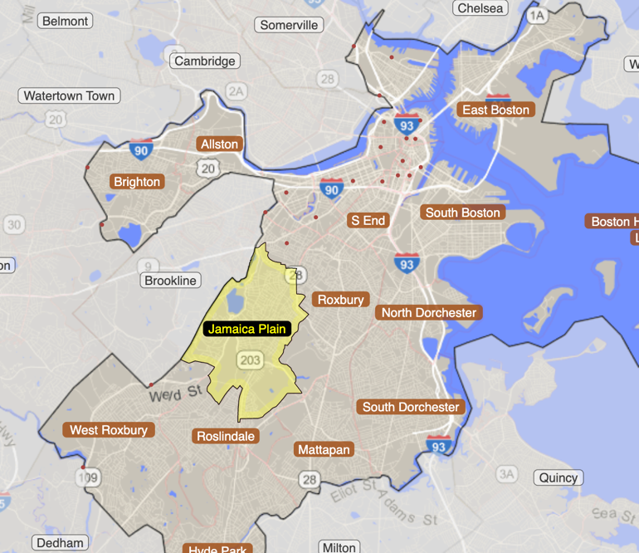Jamaica Plain is surrounded by Brookline, Roslindale, Roxbury, West Roxbury, and Mission Hill. **Figure 2** shows the neighborhood within the city of Boston, and the census tract, 120400, within the Jamaica Plain neighborhood.

**Figure 2.** Jamaica Plain and Census Tract 120400 from the Statistical Atlas

I chose to study the 120400 census tract because it had the most listings. **Table 1** shows the top ten most frequent census tracts within Boston. It is worth noting that 120400 had almost twice as many listings as the second highest census tract. This may be due to two reasons: landlords and brokers are more prolific about using Craigslist in this area and there may be duplicated listings. Since listing IDs are different for each listing, is it difficult to parse out which ones are duplicates and which ones are unique. I believe it is still worth investigating this census tract because the nature of how brokers and landlords use Craigslist (creating duplicates or more listings in general) can have a strong impact on how renters find apartments in neighborhoods and can be a useful tool in understanding the rental market for that area. Future work with this data could investigate further into whether duplicate listings make the apartment rental search easier or more difficult for renters or generally understanding the dynamics between renters and brokers and landlords.

**Table 1.** Frequency of Listings in Census Tracts in Boston

|  |  |
| --- | --- |
| Census Tract ID | Frequency |
| 120400 | 719 |
| 071101 | 399 |
| 000402 | 386 |
| 010600 | 371 |
| 091900 | 361 |
| 081400 | 321 |
| 040300 | 288 |
| 060301 | 276 |
| 020200 | 263 |
| 120301 | 251 |

#### In the News

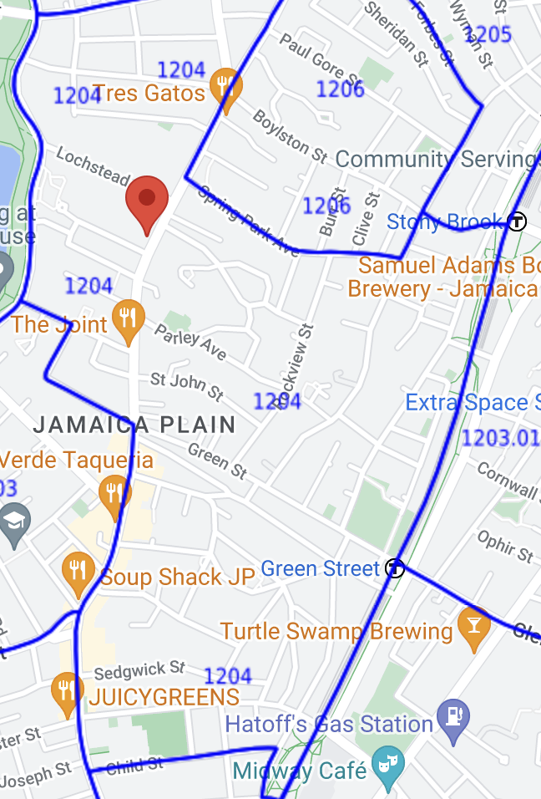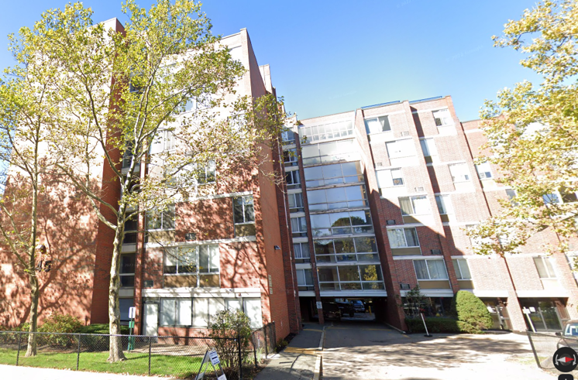 Like all of Boston, affordable housing is a topic that is prevalent in the community and the media regarding Jamaica Plain. As rental prices rise, Jamaica Plain residents must gather to fight for retaining and creating more affordable housing opportunities. For example, as seen in an article from the Bay State Banner, the Forbes Building located at 545 Centre St is at risk for increased rent because the building owner has not yet committed to renewing rents at an affordable price. The Forbes Building was constructed under the state’s 13A program which protected the affordable units. However, the program expired in 2019 and the building has been in limbo since. Residents and community activists gathered to fight for continued affordable housing so that current low-income residents would not be displaced (Lamb, 2022).

**Figure 3.** The Forbes Building

Although the site is just outside of the 120400 census tract, but still within Jamaica Plain, another example of the community push for affordable housing is the adaptive reuse of the Blessed Sacrament Church at 361 Centre St. Recently, in December 2022, the site was approved to become a mixed-use affordable housing development that will include 55 income-restricted units (Hughes, 2022). Initially, the proposal to convert the former church into housing garnered pushback from the community because of concerns that the renovated units would only provide market-rate housing. However, after the successful push for mixed-income units, former parishioners, residents, and community activists praised the decision to convert the church (Betancourt, 2021).

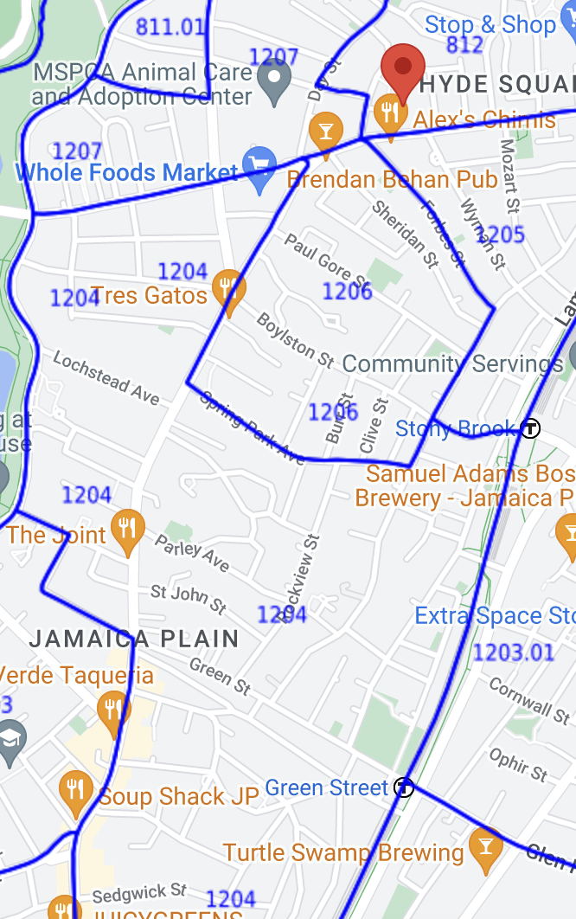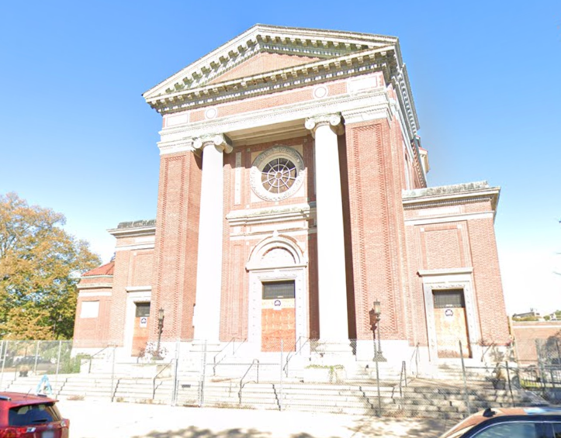

**Figure 4.** Blessed Sacrament Church

For market-rate renters in Jamaica Plain, rents increased by $200 - $400 per month from 2021 to 2022. According to a post by Stephen Quigley in the Jamaica Plain Gazette, “rents for one bedroom apartments average $2,300 per month, while two bedrooms are renting for $3,000-$3,200 per month” (2022). The housing market, especially in Jamaica Plain, has become so competitive that some renters even find themselves in bidding wars to secure an apartment. By entering a bidding war, prospective tenants choose to offer a higher rent than advertised in order to outbid the other applicants and secure an apartment.

In the context of homebuying, Jamaica Plain has remained a competitive market for buyers. From Jamaica Plain News, “there continues to be a consistent lack of inventory in Jamaica Plain. Therefore, the demand continues to be high in proportion to the supply which will keep prices relatively strong” (Ertischek, 2023). Low supply for homebuying in Jamaica Plain and Boston in general has strong implications for the rental market because that means more people will continue to rent, exacerbating the existing competitive rental market.

#### Current Affordable Housing Options in the 120400 Census Tract

With the rising rents, it is important for a community to have enough affordable housing so that low-income residents do not face displacement and economic and racial segregation are not perpetuated. To better understand Jamaica Plain’s current affordable housing options, I used the Boston Area Research Map’s Commerce & Institutions map to find subsidized housing within the 120400 census tract. The map provided only one subsidized housing, Boston Housing Authority’s property on 29 Pond St, shown in purple (**Figure 5 & Figure 6**). According to the Boston Housing Authority, 29 Pond St is a federally funded elderly/disabled development for low- and moderate-income levels with rents calculated at 30% of the resident’s income (Boston Housing Authority, n.d.).

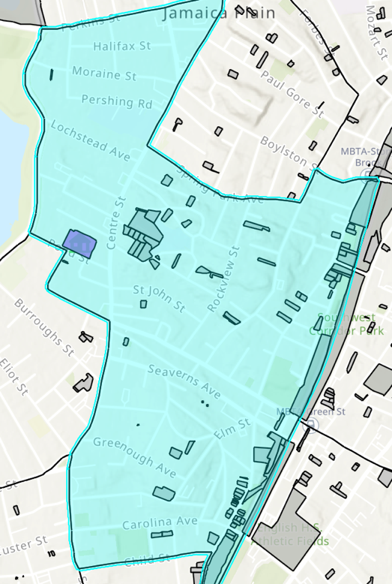

**Figure 5.** 120400 Census Tract with Affordable Housing Building

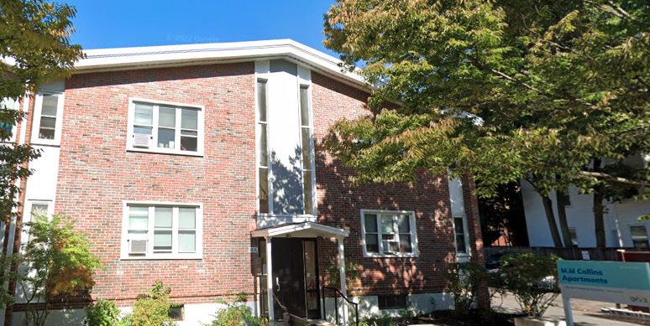

**Figure 6**. Boston Housing Authority – 29 Pond St

In addition to BHA’s public housing, the Jamaica Plain Neighborhood Development Corporation (JPNDC) also provides affordable housing for families. One of their development projects within the 120400 census tract is the Pondview Apartments at 560 Centre St as shown in **Figure 7**. This development contains 60 units (one-to-three-bedroom apartments) and was completed in 2000. JPNDC considers this development “a major victory in avoiding displacement of low-income residents” (JPNDC, n.d.). Since this development belongs to JPNDC, they do not run the risk of expiring affordability requirements and are able to provide long-term affordability to residents.

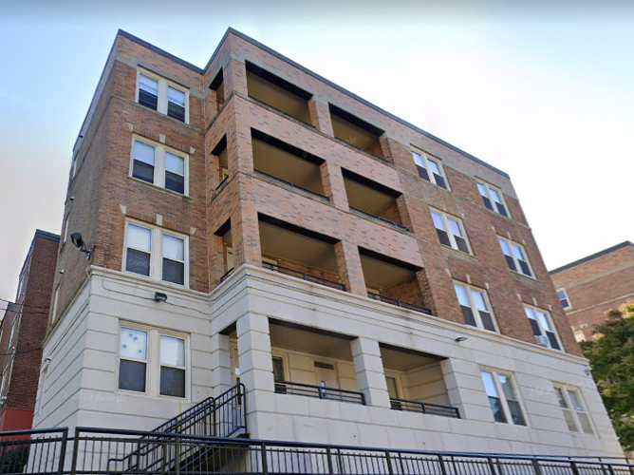

**Figure 7.** JPNDC's Pondview Development

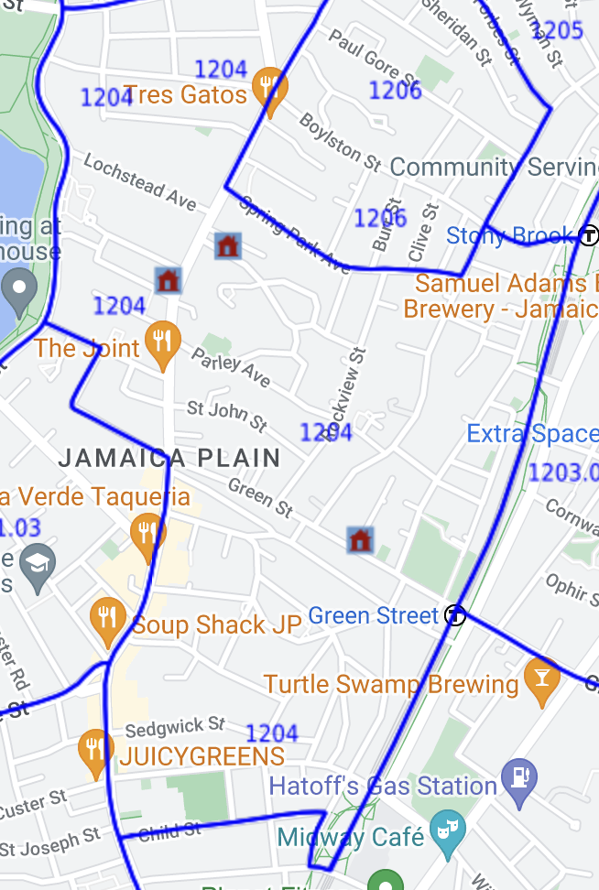 Developments built with Low Income Housing Tax Credit (LIHTC) are another affordable housing option. LIHTC was established in 1986 via the Tax Reform Act and provides tax credits “for the acquisition, rehabilitation, or new construction of rental housing targeted to lower-income households” (HUD User, n.d.). Based on data from HUD, there are three developments within the 120400 census tract that are LIHTC projects: 24 Robinwood Ave, the former Bowditch School, and JPNDC’s Pondview Development. For the Robinwood development, there are 10 total units, and all 10 are low-income units. For the Bowditch school, there are 50 units, with 45 of them being low-income units. It is also helpful to note that the 120400 census is not considered a Qualified Census Tract (QCT). A QCT is “any census tract […] in which at least 50% of households have an income less than 60% of the Area Median Gross Income” (National Low Income Coalition, 2021). However, 120400 is considered a Difficult Development Area (DDA), which “are areas with high development costs relative to incomes” (National Low Income Coalition, 2021). Developers who commit to building in DDAs receive extra subsidies and incentives to build affordable housing compared to developers who do not build in DDAs.

**Figure 8.** LIHTC Developments in the 120400 Census Tract

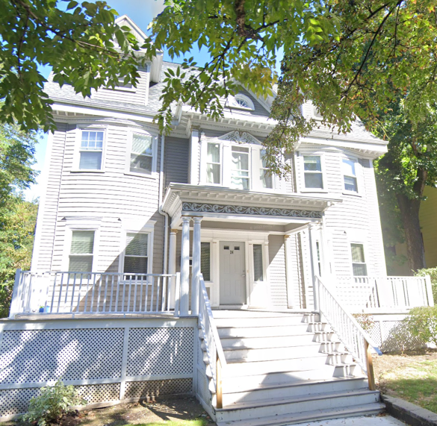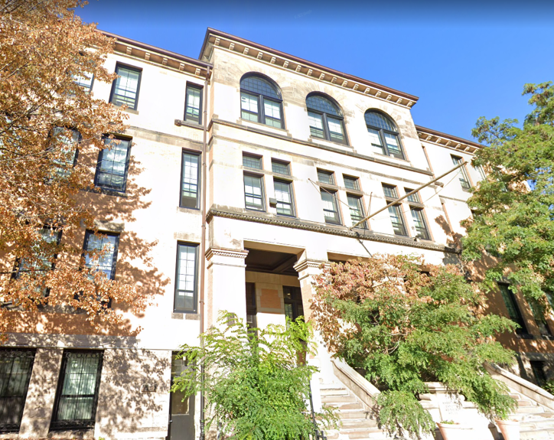

**Figure 9.** 24 Robinwood Ave & the former Bowditch School

# Implications for the Craigslist Listings Data

It is vital to have a holistic understanding of the rental market within Jamaica Plain and Boston in general. If we are only looking at Craigslist data without considering housing options and developments outside of the data set, we may overlook the needs of low-income families who require affordable housing and risk displacement. Based on the Craigslist dataset, the average rent for a one-bedroom apartment (assuming a one-bedroom is between 700 square feet and 900 square feet) was $2,276.77. For a two-person household at the 30% Area Median Income (AMI) level (an income of $33,650), they would not be able to afford the average rent of the Craigslist listings for a one-bedroom apartment and would be considered severely cost burdened. Even at 80% AMI (an income of $89,750), they would be considered cost burdened. Therefore, most Craigslist listings are not affordable for low-income families (City of Boston, n.d.).

The Craigslist listing data is a helpful tool in understanding the ever-changing market-rate rental housing costs and supply, which can influence affordable housing. As more people encounter increasing rents, there will be a continued push towards affordable housing for a growing number of people. As new policies are introduced (for example, rent stabilization), we must keep the lowest-income families in mind as they have been traditionally forgotten or excluded from affordable housing options such as housing choice vouchers and inclusionary zoning.

Additionally, the Craigslist listings offer an interesting insight into how brokers and landlords function. As we’ve already seen, some brokers and landlords aggressively post duplicates of the same listing, most likely in the hopes that their listings will be seen by as many people as possible. However, one of the downfalls of the high number of listings is that it increases the difficulty of the search for renters because there are more listings to sift through, along with existing scams and fake listings. The housing search is already difficult for market-rate renters, which means that for renters with a voucher, it is substantially more challenging. It is unclear whether landlords or brokers that post their listings on Craigslist will accept vouchers, thus it is likely not an effective tool for families seeking housing with vouchers. This ultimately speaks to the inherent bias of the tool that caters more towards market-rate renters.

Finally, it would be advantageous to understand where the Craigslist listings are located in relation to the housing developments that were previously mentioned. Mixed-income neighborhoods, especially when combined with intentional initiatives to foster increased social connections between families with different income levels, can have a positive impact on the community. Mixed-income neighborhoods can prevent concentrated poverty, foster more economic wealth and diversity, and potentially bolster the mental health of low-income families. However, mixed-income neighborhoods also risk increasing and amplifying gentrification. Therefore, as we continue to study the rental market in Jamaica Plain, it is essential to understand how mixed-income communities function and ensure that low-income families are not forgotten.

# References

Betancourt, S. (2021, October 18). *Massive Jamaica Plain Church To Become Affordable Housing And Performance Space.* GBH. <https://www.wgbh.org/news/local-news/2021/10/18/massive-jamaica-plain-church-to-become-affordable-housing-and-performance-space>

Boston Area Research Map. (n.d.). *Boston Area Research Map*. BARI. <https://boston-area-research-map-nu.hub.arcgis.com/>

Boston Housing Authority. (n.d.). *Pond Street*. <https://www.bostonhousing.org/en/HousingDevelopmentDetail.aspx?hid=155&Bid=8>

City of Boston (n.d.). *Income-Restricted Housing*. Mayor’s Office of Housing. <https://www.boston.gov/income-restricted-housing-guide>

Ertischek, S. (2023, January 13). *Jamaica Plain Realters Provide Their Market Outlook for 2023.* Jamaica Plain News. <https://www.jamaicaplainnews.com/2023/01/13/jamaica-plain-realtors-provide-their-market-outlook-for-2023/552366>

Federal Communications Commission. (.n.d). *2020 Census Blocks by State*. <https://www.fcc.gov/general/2020-census-blocks-state>

HUD User. (n.d.). *Low-Income Housing Tax Credit (LIHTC)*. Office of Policy Development And Research (PD&R). <https://www.huduser.gov/portal/datasets/lihtc.html>

Hughes, L. (2022, December 16). *Jamaica Plain’s Blessed Sacrament Church to become affordable housing*. Boston Agent Magazine. <https://bostonagentmagazine.com/2022/12/16/jamaica-plains-blessed-sacrament-church-to-become-affordable-housing/>

JPNDC. (n.d.). *Real Estate Portfolio: Family Housing*. <https://jpndc.org/real-estate-portfolio/real-estate-portfolio-family-housing/>

Lamb, A. (2022, October 26). *Jamaica Plain tenants fight for affordable rents*. The Bay State Banner. <https://www.baystatebanner.com/2022/10/26/jamaica-plain-tenants-fight-for-affordable-rents/>

Lamb, A. (2022, August 17). *Affordable housing plan for JP church*. The Bay State Banner. https://www.baystatebanner.com/2022/08/17/affordable-housing-plan-for-jp-church/

National Low Income Housing Coalition. (2021). *HUD Designates Difficult Development Areas and Qualified Census Tracts for 2022.* <https://www.nlihc.org/resource/hud-designates-difficult-development-areas-and-qualified-census-tracts-2022>

Quigley, S. (2022, September 23). *Boston ranks among most expensive cities; rents show sharp increase*. Jamaica Plain Gazette. <https://jamaicaplaingazette.com/2022/09/23/boston-ranks-among-most-expensive-cities-rents-show-sharp-increase/>

Statistical Atlas. (.n.d). *Overview of the Boston Area (Metro Area)*. <https://statisticalatlas.com/metro-area/Massachusetts/Boston/Overview>